**Online MAT150 Second Exam**

**Name: Shafee Ahmed MAT 150**

**1.** Which one of the following charts represents a probability distribution **(5 points):**

|  |  |
| --- | --- |
| **X** | **P(x)** |
| **0** | **-0.1** |
| **1** | **0.1** |
| **2** | **0.4** |
| **3** | **0.6** |

|  |  |
| --- | --- |
| **X** | **P(x)** |
| **0** | **0.3** |
| **1** | **0.2** |
| **2** | **0.1** |
| **3** | **0.35** |

a) b) c) d)

|  |  |
| --- | --- |
| **X** | **P(x)** |
| **0** | **0.1** |
| **1** | **0.2** |
| **2** | **0.4** |
| **3** | **0.1** |

|  |  |
| --- | --- |
| **X** | **P(x)** |
| **0** | **0** |
| **1** | **0** |
| **2** | **1** |
| **3** | **0** |

a sum = 0.8 b sum = 1 c sum = 1 d sum = 0.95

**Ans. B**

Answer is B because P(x) is between 0 and 1, and sum of P(x) is 1. C has p(x) value below 0, which is disqualified.

**2.** The number of violent crimes committed in a day possesses a distribution with a mean of 2.8 crimes per day and a standard deviation of 4 crimes per day. A random sample of 100 days was observed, and the sample mean number of crimes for the sample was calculated. Describe the sampling distribution of the sample means. **(5 points)**

1. shape unknown with mean of 2.8 and a standard deviation of 0.4
2. approximately normal with mean of 2.8 and standard deviation of 4
3. shape unknown with mean of 2.8 and standard deviation of 4
4. approximately normal with mean of 2.8 and standard deviation of 0.4

**Ans. D**

3. From the table below, find Prof. Xin expected value of lateness. **(5 points)**

|  |  |
| --- | --- |
| Lateness | P(Lateness) |
| On Time | 4/5 |
| 1 Hour Late | 1/10 |
| 2 Hours Late | 1/20 |
| 3 Hours Late | 1/20 |

0 * 4/5 + 1 * 1/10 + 2 * 1/20 + 3 * 1/20 = 0.35

**Ans. 0.35**

4. A small start up tech company has 4 customer service telephone lines. Let $x$ denote the number of phone lines in use at any given time. Suppose that the probability distribution of $x$ is as follows: **(10 points)**

|  |  |  |  |  |  |
| --- | --- | --- | --- | --- | --- |
| $$x$$ | $$P\left(x\right)$$ | x * p(x) |  |  |  |
| 0 | 0.10 | 0 |  |  |  |
| 1 | 0.16 | 0.16 |  |  |  |
| 2 | *A = 0.21* | 0.42 |  |  |  |
| 3 | 0.31 | 0.93 |  |  |  |
| 4 | 0.22 | 0.88 |  |  |  |

a.) Determine the value of $a$ if the data above represent a discrete probability distribution.

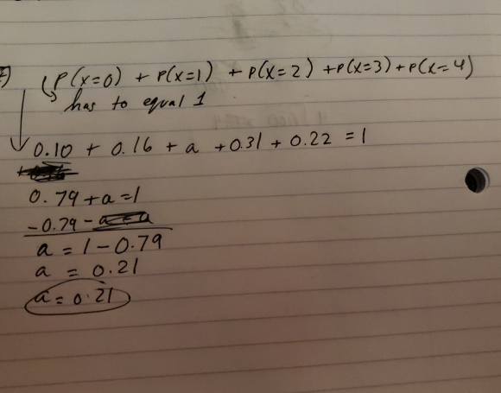\

Ans. a = 0.21

b.) Calculate and interpret the expected value of $x$.

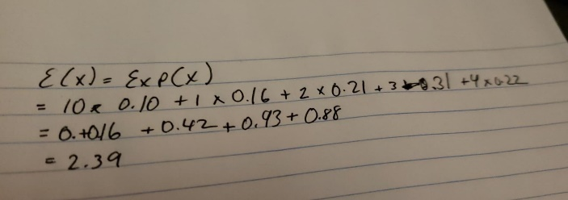

Ans. x = 2.39

c.) Calculate the standard deviation of $x$.

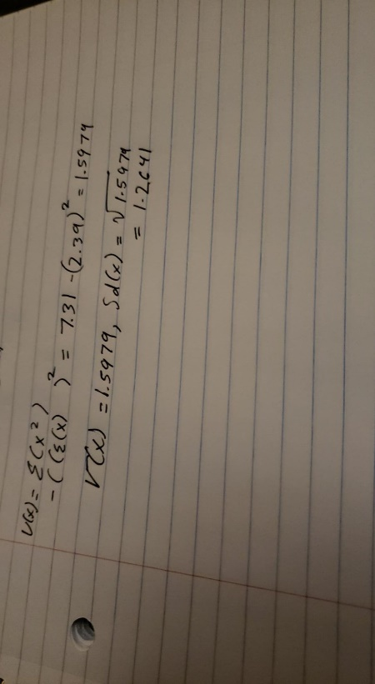

Sd(x) = 1.2641

5. A history lecture hall class has 15 students. There is a 15% absentee rate per class meeting.

a.) Find the probability that exactly one student will be absent from class. **(5 points)**

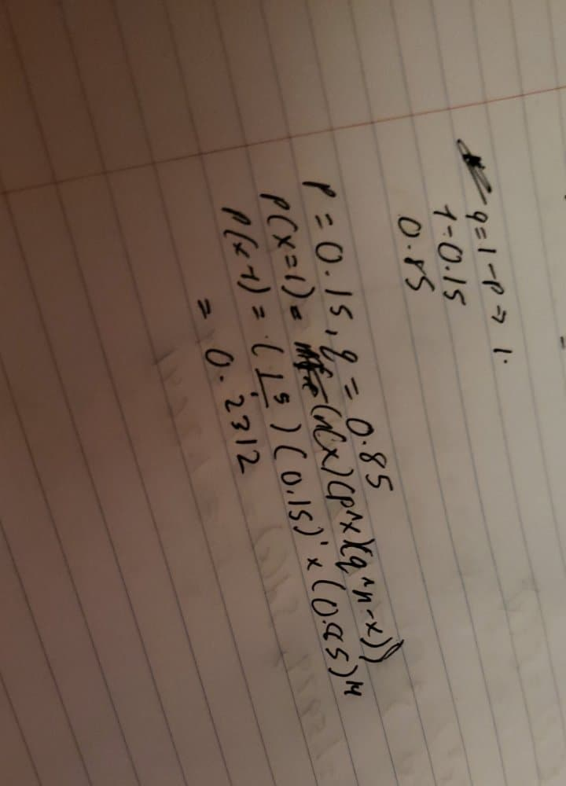

Ans. p(x =1 ) = 0.2312

b.) Find the probability that at least 2 students will be absent from class. **(10 points)**

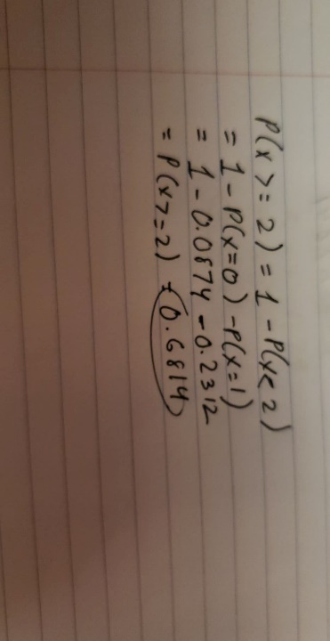

Ans. p(x >= 2) = 0.6814

6. Three hundred viewers were asked if they were satisfied with TV coverage of a recent disaster. **(15 points)**

|  |  |  |  |
| --- | --- | --- | --- |
|  | Female (F) | Male (M) | TOTAL |
| Satisfied (S) | 80 | 55 | 135 |
| Not Satisfied (N) | 120 | 45 | 165 |
| TOTAL | 200 | 100 | 300 |

If a viewer is to be randomly selected from those surveyed.

1. Find the probability that the viewer is satisfied.

Ans. P(satisfied) =135 / 300 = **0.45**

1. Find the probability that the viewer is a female or the viewer is not satisfied.

P(female)=200 / 300

P(not satisfied) = 165 / 300 = 165/300

P(female and not satisfied)= female and not satisfied / total = 120 / 300

= (200/300) + (165/300) + (120/300)

= 0.8167

Ans. 0.8167

1. Find the probability that the viewer is satisfied given that the viewer is male.

P(satisfied/male) = 55 / 100

Ans. 0.55

6. Find P(Z > -1.50) **(5 points)**

P (z – 1.5) = 1 – 0.0668

= 0.9332

Ans. 0.9332

7. According to a National Health Survey, American men’s heights are normally distributed with a mean given by $μ=69.7$ inches and a standard deviation given by $σ=2.8$ inches.

a). If a man is randomly selected, find the probability that his height is more 72 inches. **(10 pints)**

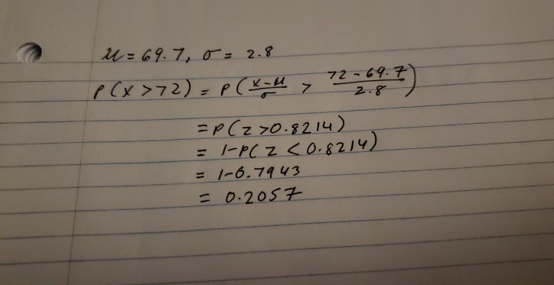

Ans. 0.2057

b). If a man is randomly selected, find the probability that his height is between 68 and 72 inches. **(10 points)**

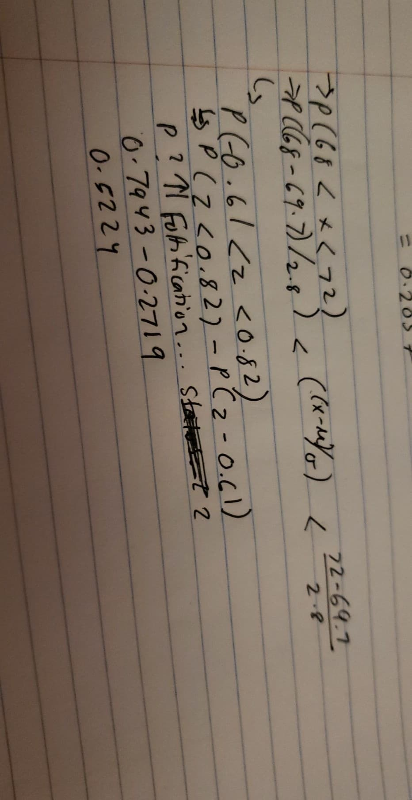

Ans. 0.5224

8. Suppose the amount of a popular sport drink in bottles leaving the filling machine has a normal distribution with mean 101.5 milliliters (mL) and standard deviation 1.6. If 36 bottles are randomly selected, find the probability that the mean content is less than 102.1 mL **(10 points)**

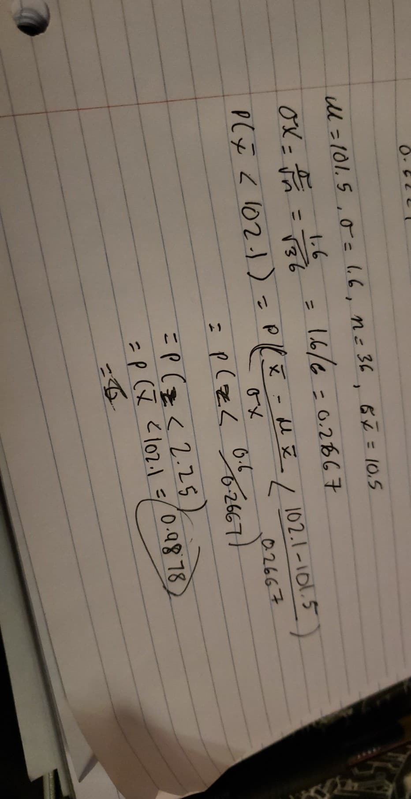

Ans. 0.9878

9. The data below are the passing scores on an Algebra exam in one class. For this question, round all answers to the nearest **tenth, as needed**. **(15 points)**

60 68 88 76 60 92 92 92 88 60 68 92 88

92 64 60 76 64 92 88 76 60 60 64 60 88

76 64

**Construct the frequency table by using *five* classes.**

|  |  |  |  |  |
| --- | --- | --- | --- | --- |
| Class Limit | *f* | Class Midpoint | Cumulative Frequency | Class Boundary |
| 51 - 60 | 7 | 55.5 | 7 | 50.5 – 60.5 |
| 61 – 70 | 6 | 65.5 | 13 | 60.5 – 70.5 |
| 71 – 80 | 4 | 75.5 | 17 | 70.5 – 80.5 |
| 81 – 90 | 5 | 85.5 | 23 | 80.5 – 90.5 |
| 91 – 100 | 6 | 95.5 | 28 | 90.5 – 100.5 |

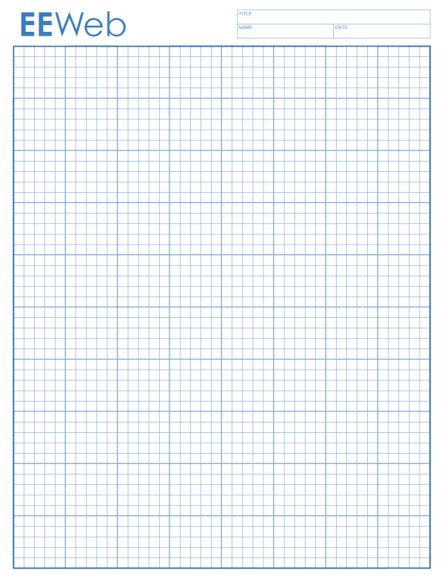(a) Create a frequency polygon to represent the above data. (b) Create an ogive to represent the above data.

